LIST OF EXPERIMENTS

- Realize all gates using NAND and NOR gates.
- Realize Half Adder and Full Adder using logic gates.
- To realize Half Subtractor and Full Subtractor using logic gates.
- To realize priority encoder.
- To realize BCD adder.
- To realize Multiplexer and Demultiplexer using only NAND gates.
- To realize J-K flip flop using logic gates or by using kit.
- To realize decade counter using flipflop IC or by using kit.
- To study 4-bit ALU.
- To realize serial adder.

Beyond Curriculum

11. To realize 2-bit Magnitude Comparator.
- To realize a Boolean function using IC 74153.
- To realize binary to gray and gray to binary code converter.
14. To design T flip flop using basic gates or on kit.

INTRODUCTION FOR CONNECTION ON BREADBOARD
The Breadboard:
The breadboard consists of two terminal strips and two bus strips (often broken in the centre). Each bus strip has two rows of contacts. Each of the two rows of contacts are a node. That is, each contact along a row on a bus strip is connected together (inside the breadboard). Bus strips are used primarily for power supply connections, but are also used for any node requiring a large number of connections. Each terminal strip has 60 rows and 5 columns of contacts on each side of the centre gap. Each row of 5 contacts is a node. You will build your circuits on the terminal strips by inserting the leads of circuit components into the contact receptacles and making connections with 22-26 gauge wire. There are wire cutter/strippers and a spool of wire in the lab. It is a good practice to wire +5V and 0V power supply connections to separate bus strips. The 5V supply MUST NOT BE EXCEEDED since this will damage the ICs(Integrated circuits) used during the experiments. Incorrect connection of power to the ICs could result in them exploding or becoming very hot - with the possible serious injury occurring to the people working on the experiment! Ensure that the power supply polarity and all components and connections are correct before switching on power .

Building the Circuit:
Throughout these experiments we will use TTL chips to build circuits. The steps for wiring a circuit should be completed in the order described below:
1. Turn the power (Trainer Kit) off before you build anything!
2. Make sure the power is off before you build anything!
3. Connect the +5V and ground (GND) leads of the power supply to the power and ground bus strips on your breadboard.
4. Plug the chips you will be using into the breadboard. Point all the chips in the same direction with pin 1 at the upper-left corner. (Pin 1 is often identified by a dot or a notch next to it on the chip package)
5. Connect +5V and GND pins of each chip to the power and ground bus strips on the breadboard.
6. Select a connection on your schematic and place a piece of hook-up wire between corresponding pins of the chips on your breadboard. It is better to make the short connections before the longer ones. Mark each connection on your schematic as you go, so as not to try to make the same connection again at a later stage.
7. Get one of your group members to check the connections, before you turn the power on.
8. If an error is made and is not spotted before you turn the power on. Turn the power off immediately before you begin to rewire the circuit.
9. At the end of the laboratory session, collect you hook-up wires, chips and all equipment and return them to the demonstrator.
10. Tidy the area that you were working in and leave it in the same condition as it was before you started.
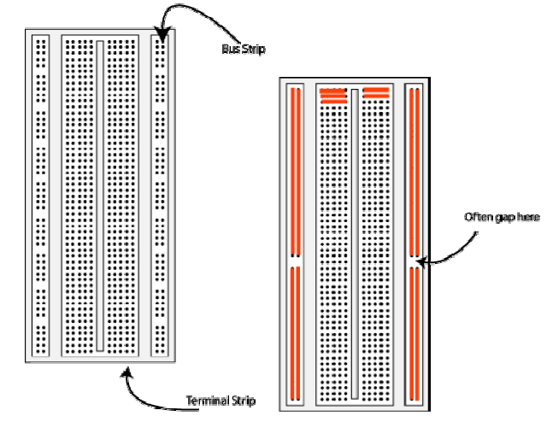

Common Causes of Problems:
1. Not connecting the ground and/or power pins for all chips.
2. Not turning on the power supply before checking the operation of the circuit.
3. Leaving out wires.
4. Plugging wires into the wrong holes.
5. Driving a single gate input with the outputs of two or more gates.
6. Modifying the circuit with the power on.
In all experiments, you will be expected to obtain all instruments, leads, components at the start of the experiment and return them to their proper place after you have finished the experiment. Please inform the demonstrator or technician if you locate faulty equipment. If you damage a chip, inform a demonstrator, don't put it back in the box of chips for somebody else to use.

Example Implementation of a Logic Circuit:
Build a circuit to implement the Boolean function F = /(/A./B), please note that the notation /A refers to . You should use that notation during the write-up of your laboratory experiments.
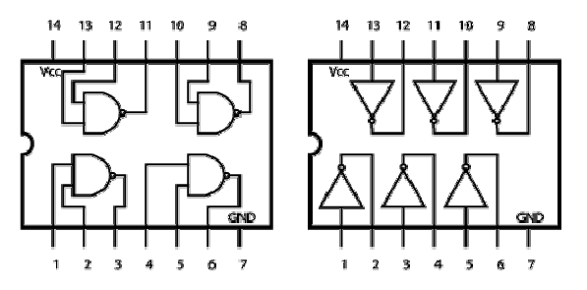

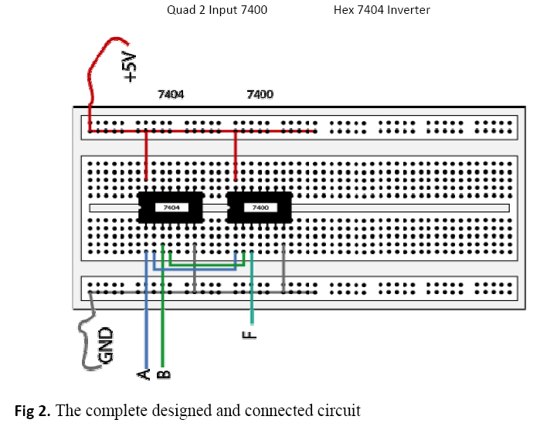

STUDENTS GUIDELINES-
There are 3 hours allocated to a laboratory session in Digital Electronics. It is a necessary part of the course at which attendance is compulsory. Here are some guidelines to help you perform the experiments and to submit the
reports:
1. Read all instructions carefully and carry them all out.
2. Ask a demonstrator if you are unsure of anything.
3. Record actual results (comment on them if they are unexpected!)
4. Write up full and suitable conclusions for each experiment.
5. If you have any doubt about the safety of any procedure, contact the
demonstrator beforehand.
6. THINK about what you are doing!

USEFUL IC PIN DETAILS

IC number | Details of IC
7400 | 2 input NAND Gate
7402 | 2 input NOR Gate
7408 | 2 input AND Gate
7404 | Inverter
7432 | Quad 2 input OR Gates
7486 | Quad 2 input EX-OR Gate
7411 | 3 input AND
7410 | 3 input NAND gate
7476 | Dual J-K Flip Flop
7474 | Dual D Flip Flop
7483 | 4 bit Parallel Adder
74153 | Dual 4 input Multiplexer

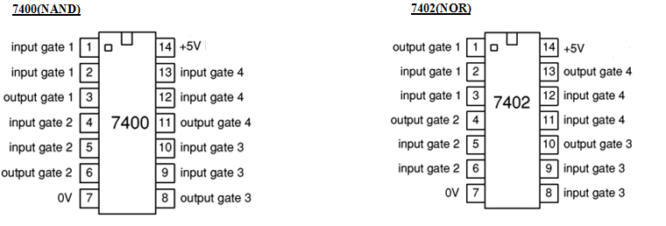
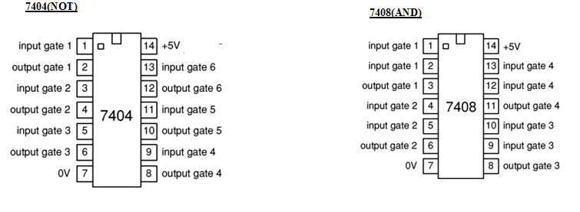

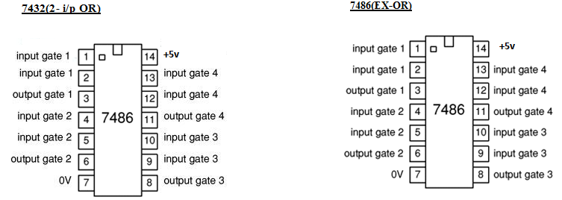

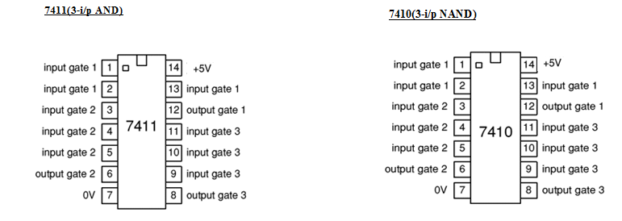

7474 Dual D Flip-Flop: 7476 Dual J-K Flip-Flop:
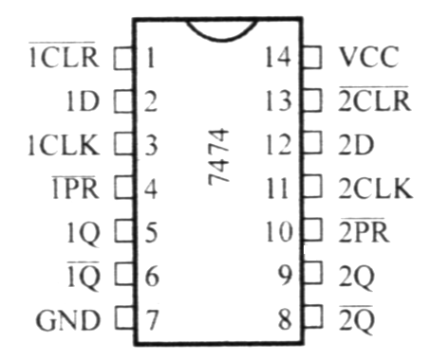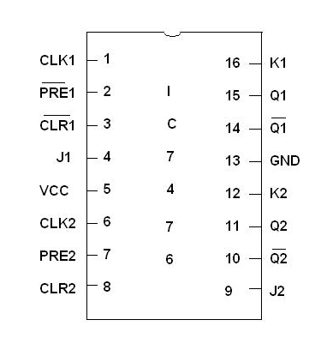

7483 Parallel adder IC: 74153 DUAL 4x1 MUX IC
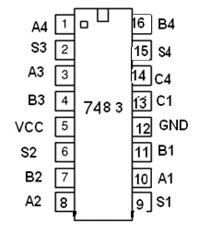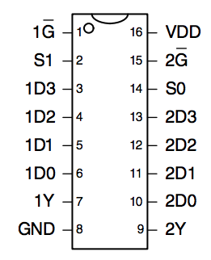

EXPERIMENT No.1
REALIZATION OF GATES USING UNIVERSAL GATES

AIM: To verify all gates using NAND and NOR gates

APPARATUS: Breadboard, IC 7400 (NAND), IC 7402(NOR), LEDs, +-5V power supply, Connecting wires.

THEORY: NAND Gate: The NAND gate represents the complement of the AND operation. Its name is an abbreviation of NOT AND. The graphic symbol for the NAND gate consists of an AND symbol with a bubble on the output, denoting that a complement operation is performed on the output of the AND gate as shown in Fig 1.1
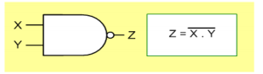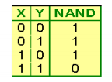
Fig 1.1 NAND gate

NOR Gate: The NOR gate represents the complement of the OR operation. Its name is an abbreviation of NOT OR. The graphic symbol for the NOR gate consists of an OR symbol with a bubble on the output, denoting that a complement operation is performed on the output of the OR gate. The truth table and the graphic symbol of NOR gate is shown in the fig 1.2.
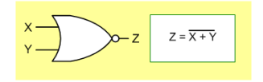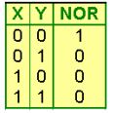
Fig 1.2 NOR gate
NAND and NOR Gates are called as universal gates as all other gates can be implemented using these two gates

NAND gate as universal gate:
. 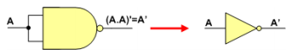
a) NAND as NOT gate
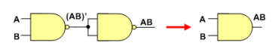
b) NAND as AND gate
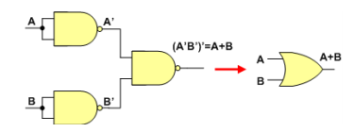
c) NAND as OR gate
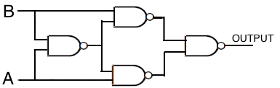
d) NAND as XOR gate
Fig 1.3 (a),(b),(c),(d)
NOR gate as universal gate:
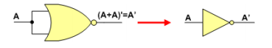
a) NOR as NOT Gate

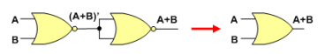
b) NOR as OR Gate

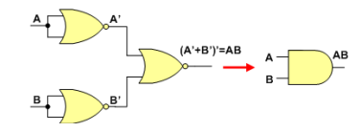
c) NOR as AND Gate

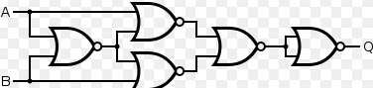
d) NOR as XOR GATE
Fig 1.4 (a), (b), (c), (d)
Truth table of all the gates
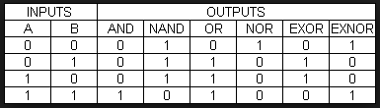
Table 1.1

Pin Configuration of IC-7402(NOR), IC-7400(NAND):
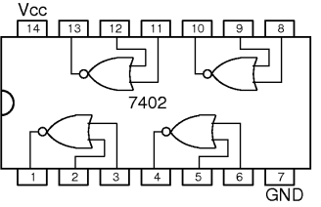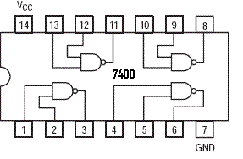
Fig 1.5 Pin Configuration of IC used
PROCEDURE:
1. Connections are made as per the circuit diagram
2. Switch on the power supply
3. Apply different combinations of inputs and observe the outputs; compare the outputs with the truth tables.

PRECAUTIONS:
- All ICs should be checked before starting the experiment.
- All the connection should be tight.
- Always connect ground first and then the supply.
- Switch off the power supply after completion of the experiment.

RESULT:
NAND and NOR gates have been studied as universal gates.

VIVA-VOCE QUESTIONS:
1. Why NAND & NOR gates are called universal gates?
2. Give the truth table for EX-NOR and why it is called Extended OR?
3. What is difference between logical and Arithmetic operation?
4. What are Basic Gates?

EXPERIMENT No.2
REALIZATION OF HALF ADDER AND FULL ADDER

AIM: To realize Half Adder and Full Adder using basic gates.

APPARATUS:
Breadboard, IC 7486(XOR), IC 7408 (AND), IC 7432(OR), LEDs, 5V power supply, connecting wires.

THEORY:
HALF ADDER- A combinational logic circuit that performs the addition of two data bits, A and B, is called a half-adder. Addition will result in two output bits; one of which is the sum bit, S, and the other is the carry bit, C as shown in fig 2.1. The Boolean functions describing the half-adder are:
S =AB
C = A B
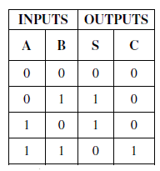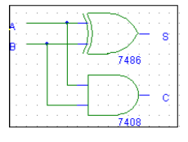
Fig 2.1 HA circuit diagram and truth table

FULL ADDER- The half-adder does not take the carry bit from its previous stage into account. This carry bit from its previous stage is called carry-in bit. A combinational logic circuit that adds two data bits, A and B, and a carry-in bit, Cin , is called a full-adder
S = (x ⊕ y) ⊕ Cin
C = xy + Cin (x ⊕ y)

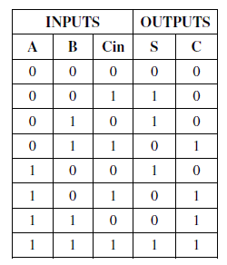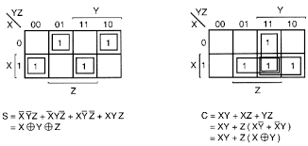

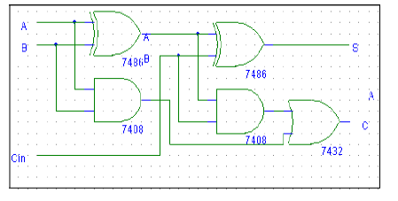
Fig 2.2 FA Truth Table and circuit implementation
PROCEDURE:
1. Verify the gates.
2. Make the connections as per the circuit diagram.
3. Switch on VCC and apply various combinations of input according to truth table.
4. Note down the output readings for half adder and full adder.
Sum and the carry bit for different combinations of inputs verify their truth tables.

Pin Configuration of IC-7486(XOR), IC-7432(OR), IC-7408(AND):

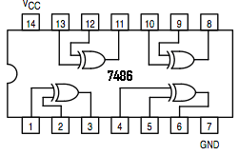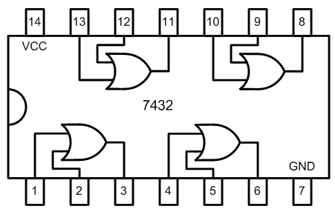
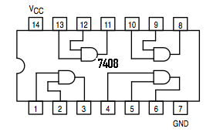
Fig 2.3 Pin Configuration of IC used

PRECAUTIONS:
- All ICs should be checked before starting the experiment.
- All the connection should be tight.
- Always connect ground first and then the supply.
- Switch off the power supply after completion of the experiment.

RESULT:
HA and FA have been realized using basic gates and their truth table has been verified.

VIVA-VOCE QUESTIONS:
1. Prove that Sum of a full adder is a XOR Gate between its inputs.
2. State the difference between Half Adder and Full Adder.
3. Can we design a full adder using two half adders?
4. What are Combinational Circuits?

EXPERIMENT No. 3
REALIZATION OF HALF SUBTRACTOR AND FULL SUBTRACTOR
AIM: To realize Half Subtractor and full Subtractor.

APPARATUS: Breadboard, IC 7486(XOR), IC 7408 (AND), IC 7404(NOT),IC 7432(OR), LEDs, 5V power supply, connecting wires.

THEORY:
HALF SUBTRACTOR: Subtracting a single-bit binary value B from another A (i.e. A -B ) produces a difference bit D and a borrow out bit B-out. This operation is called half subtraction and the circuit to realize it is called a half subtractor. The Boolean functions describing the half-Subtractor are:
S =A ⊕ B
C = A’ B
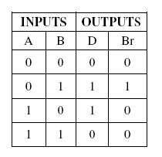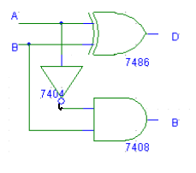
Fig 3.1 Truth table and Circuit diagram of HS

FULL SUBTRACTOR: Subtracting two single-bit binary values, B, Cin from a single-bit value A produces a difference bit D and a borrow out Br bit. This is called full subtraction.
The Boolean functions describing the full-subtracter are:
D = (x ⊕ y) ⊕ Cin
Br= A’B + A’(Cin) + B(Cin)

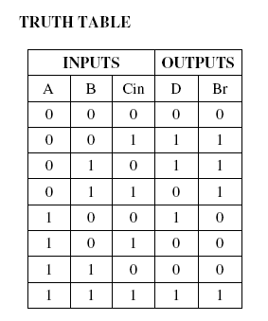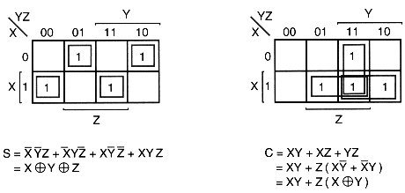
Table3.2

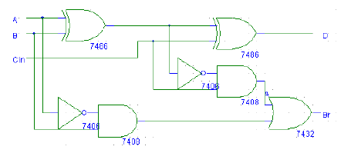
Fig 3.2 Truth table and Circuit implementation of FS

Pin Configuration of IC-7486(XOR), IC-7432(OR), IC-7408(AND):

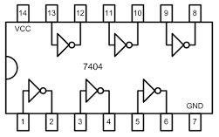
Fig 3.3 Pin diagrams of IC used

PROCEDURE:
• Check all the components for their working.
• Insert the appropriate IC into the IC base.
• Make connections as shown in the logic diagram.
• Verify the results and observe the outputs.

PRECAUTIONS:
All ICs should be checked before starting the experiment.
- All the connection should be tight.
- Always connect ground first and then the supply.
- Switch off the power supply after completion of the experiment.

RESULT:
Half Subtractor and Full Subtractor have been studied and their truth table has been verified.

VIVA-VOCE QUESTIONS:
1. What is difference between half subtractor and full subtractor?
2. List down the ICs that are used for implementation of Full subtractor?
3. Which method of subtraction is used in computer system?

EXPERIMENT No. 4
REALIZATION OF PRIORITY ENCODER

AIM: To realize priority encoder using basic Gates.

APPARATUS: Breadboard, IC 7408 (AND), IC 7404(NOT), IC 7432(OR), LEDs, 5V power supply, connecting wires.

THEORY: The priority encoder is an encoder circuit that includes the priority function. The operation of priority encoder is such that if to or more inputs are equal to 1 at the same time the input having the highest priority will take precedence. The 4-input priority encoder has 4 inputs and 3 outputs. ‘V’ is a valid-bit indicator that is set to 1 when one or more inputs are equal to 1. If all inputs are zero, there is no valid input and V is equal to 0. The other two outputs are not inspected when V equals 0 and are specified as don’t care conditions.

DESIGNING OF PRIORITY ENCODER:

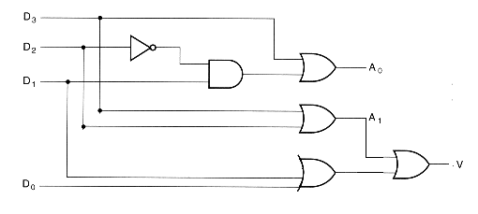

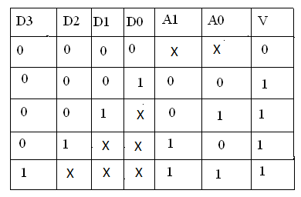
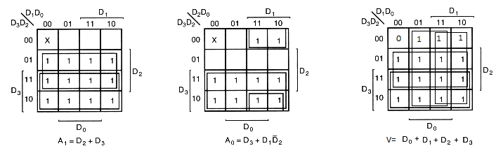
Fig 4.1 Logic diagram along with K-Map minimization

PROCEDURE:
• Check all the components for their working.
• Insert the appropriate IC into the IC base.
• Make connections as shown in the logic diagram.
• Verify the results and observe the outputs.

PRECAUTIONS:
All ICs should be checked before starting the experiment.
- All the connection should be tight.
- Always connect ground first and then the supply.
- Switch off the power supply after completion of the experiment.

RESULT:
Priority Encoder has been studied and its truth table has been verified.

VIVA-VOCE QUESTIONS:
- What is an encoder?
- State the difference between simple encoder and priority encoder.
- Specify the applications of Encoder and decoder.
- How an encoder is different from a multiplexer? .

EXPERIMENT No. 5
REALIZATION OF BCD ADDER

AIM: To realize BCD adder using parallel adder.

APPARATUS: Breadboard, IC 7483 (4-bit Parallel Adder), IC 7408 (AND), IC 7432(OR), LEDs, 5V power supply, connecting wires.

THEORY: BCD Adder is a combinational circuit that adds two BCD digits and produces a sum digit in BCD. Suppose we apply two BCD digits to a four-bit binary adder. The adder will form the sum in binary and produce a result that ranges from 0 through 19. These binary numbers are labeled by symbols K, Z8, Z4, Z2, and Z1. K is the carry, and the subscripts under the letter Z represent the weights 8, 4, 2, and 1 that can be assigned to the four bits in the BCD code when the binary sum is equal to or less than 1001, the corresponding BCD number is identical, and therefore no conversion is needed. When the binary sum is greater than 1001, we obtain an invalid BCD representation. The addition of binary 6 (0110) to the binary sum converts it to the correct BCD representation and also produces an output carry as required. The logic circuit that detects the necessary correction can be derived from the entries in the table. It is obvious that a correction is needed when the binary sum has an output carry K = 1. The other six combinations from 1010 through 1111 that need a correction have a 1 in position Z8. To distinguish them from binary 1000 and 1001, which also have a 1 in position Z8, we specify further that either Z4 or Z2 must have a 1.The condition for a correction and an output carry can be expressed by the Boolean function
C = K + Z8.Z4 + Z8.Z2
When C = 1, it is necessary to add 0110 to the binary sum and provide an output carry for the next stage.
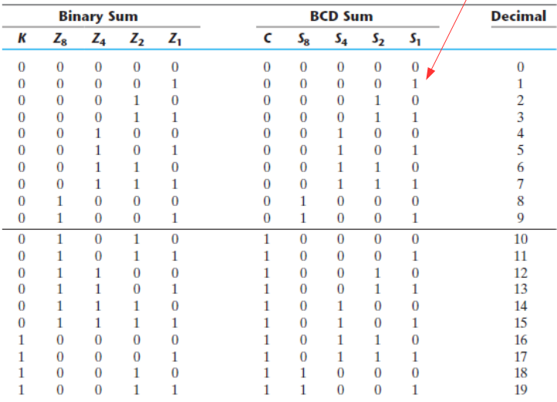
Table 5.1
CIRCUIT DIAGRAM
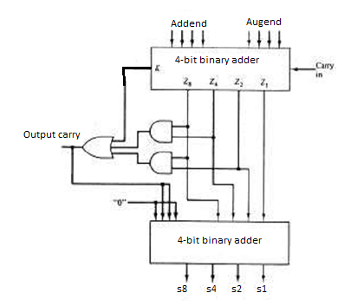
Fig 5.1 BCD adder using four bit binary adder

IC-7483( BINARY ADDER):
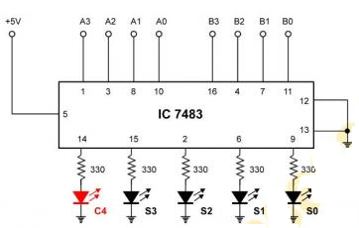
FIG 5.2 Pin configuration of IC used

PROCEDURE:
• Check all the components for their working.
• Insert the appropriate IC into the IC base.
• Make connections as shown in the circuit diagram.
• Apply augends and addend bits on A and B and cin=0(pin 13)
• Verify the results and observe the outputs.

PRECAUTIONS:
All ICs should be checked before starting the experiment.
- All the connection should be tight.
- Always connect ground first and then the supply.
- Switch off the power supply after completion of the experiment.

RESULT:
BCD Adder has been studied and its truth table has been verified.

VIVA-VOCE QUESTIONS:
- How BCD adder is different from binary adder.
- What are the advantages and drawbacks of BCD number system over binary positional systems?
- Why six is added for correction in BCD addition?
EXPERIMENT No. 6
REALIZATION OF MULTIPLEXER AND DEMULTIPLEXER

AIM: To realize Multiplexer and Demultiplexer using only NAND gates.

APPARATUS: Breadboard, IC 7400 (NAND), LEDs, 5V power supply, connecting wires.

THEORY: Multiplexers are very useful components in digital systems. They transfer a large number of information units over a smaller number of channels, (usually one channel) under the control of selection signals. Multiplexer means many to one. A multiplexer is a circuit with many inputs but only one output. By using control signals (select lines) we can select any input to the output. Multiplexer is also called as data selector because the output bit depends on the input data bit that is selected. The general multiplexer circuit has 2n input signals, n control/select signals and 1 output signal.
De-multiplexers perform the opposite function of multiplexers. They transfer a small number of information units (usually one unit) over a larger number of channels under the control of selection signals. The general de-multiplexer circuit has 1 input signal, n control/select signals and 2n output signals. De-multiplexer circuit can also be realized using a decoder circuit with enable.

REALIZATION OF 2:1 MUX 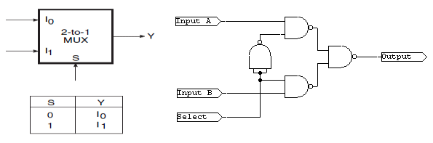
Fig 6.1 Truth Table and circuit implementation of 2:1 mux
REALIZATION OF 1:2 DEMUX

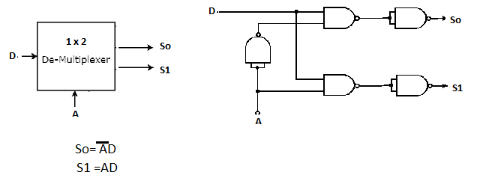
Fig 6.2 Logic Diagram and Circuit of 1:2 DMUX

PROCEDURE:
• Check all the components for their working.
• Insert the appropriate IC into the IC base.
• Make connections as shown in the circuit diagram.
• Verify the results and observe the outputs.

PRECAUTIONS:
All ICs should be checked before starting the experiment.
- All the connection should be tight.
- Always connect ground first and then the supply.
- Switch off the power supply after completion of the experiment.

RESULT:
Multiplexer and Demultiplexer have been studied and their truth table has been verified.

VIVA -VOICE QUESTIONS:
- What is multiplexer?
- What is difference between decoder and demultiplexer?
- Implement a AND gate with multiplexers.
- How many 2x1 mux required to make 8x1 mux?
EXPERIMENT No. 7
REALIZATION OF J-K FLIP FLOP

AIM: To realize J-K flip flop using logic gates or by using kit.

APPARATUS: Breadboard, IC 7400 (NAND), IC 7410 (3 input NAND), LEDs, resistor(1k), capacitor(.1uF), diode, 5V power supply, connecting wires or Omega LTB-826, patch cords.

THEORY: The JK Flip Flop is the most widely used flip flop. The sequential operation of the JK Flip Flop is same as for the RS flip-flop with the same SET and RESET input. The difference is that the JK Flip Flop does not the invalid input states of the RS Latch (when S and R are both 1).The JK Flip Flop name has been kept on the inventor name of the circuit known as Jack Kilby. S and R inputs of the RS bistable have been replaced by the two inputs called the J and K input respectively. Here J = S and K = R. The two input AND gates of the RS flip-flop is replaced by the two 3 inputs NAND gates as shown in figure 7.1(a) ,with the third input of each gate connected to the outputs at Q and Ǭ. This cross coupling of the RS Flip-Flop is used to produce toggle action. Clock will be provided by R-C circuit followed by diode as shown in figure 7.1(b).
Logic Diagram of J-K Flip Flop-
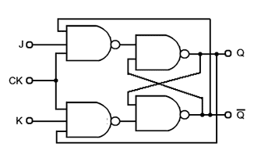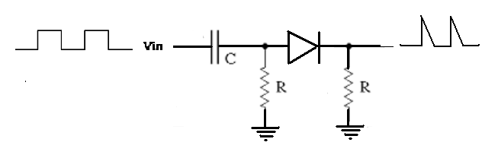
Fig 7.1 a) J-K Flip Flop b) clock provider circuit

Working of flip flop is depicted in truth table given below

Truth Table For J-K Flip Flop:
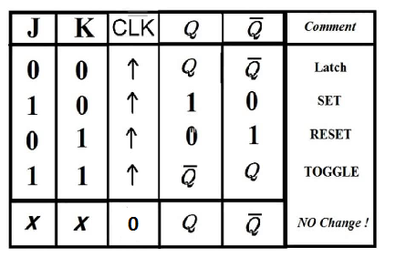

Pin Configuration of IC 7410
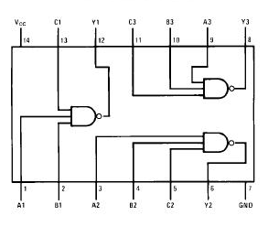
Fig 7.2 Pin configuration of IC used

PROCEDURE:
• Check all the components for their working.
• Insert the appropriate IC into the IC base.
• Make connections as shown in the circuit diagram.
• Verify the results and observe the outputs.
While working on kit
Made connections as shown in circuit diagram on kit using patch cords.

PRECAUTIONS:
- All ICs should be checked before starting the experiment.
- All the connection should be tight.
- Always connect ground first and then the supply.
- Switch off the power supply after completion of the experiment.

RESULT:
The J-K flip flop has been studied and its truth table has been verified.

VIVA -VOICE QUESTIONS:
1. Difference between sequential and combinational circuits.
2. List four Basic Flip-flop applications.
3. What advantage does a J-K Flip-flop have over an S-R?
4. What is meant by Race around condition and how we can overcome this problem?

EXPERIMENT 8
DESIGN OF DECADE COUNTER USING FLIP-FLOPS

AIM: To design Decade counter using flip flop IC or by using kit.

APPRATUS: IC’s – 7476,7400, LEDs, Connecting wires, power supply or omega LTB-857 kit and patch chords.

THEORY: An Asynchronous counter can have 2^{n}-1 possible counting states e.g. MOD-16 for a 4-bit counter, (0-15) making it ideal for use in Frequency Division applications. But it is also possible to use the basic asynchronous counter configuration to construct special counters with counting states less than their maximum output number.
This is achieved by forcing the counter to reset itself to zero at a pre-determined value producing a type of asynchronous counter that has truncated sequences.
If we take the modulo-16 asynchronous counter and modified it with additional logic gates it can be made to give a decade (divide-by-10) counter output for use in standard decimal counting and arithmetic circuits.
Such counters are generally referred to as Decade Counters. A decade counter requires resetting to zero when the output count reaches the decimal value of 10, ie. when DCBA = 1010 and to do this we need to feed this condition back to the reset input. A counter with a count sequence from binary “0000” (BCD = “0”) through to “1001” (BCD = “9”) is generally referred to as a BCD binary-coded-decimal counter.
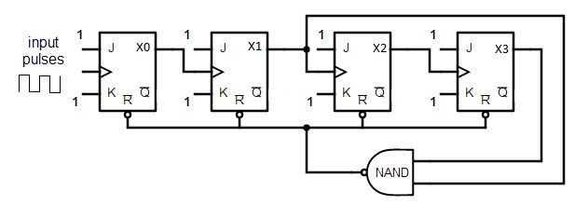
Fig 8:1 Decade Counter

PIN CONFIGURATION OF IC-7476
Fig 8.2 Pin Configuration of IC Used

PROCEDURE:
1. Connections are made as per the circuit diagram
2. Switch on the power supply.
3. Apply clock pulses and note the outputs after each clock pulse
On kit: made connections using patch cord.

PRECAUTIONS:
1. All the connections should be made properly.
2. IC should not be reversed.

RESULT: Decade counter has been designed and its truth table is verified.

VIVA -VOICE QUESTIONS:
1. Why do we need counters in digital electronics?
2. Why they are called as BCD counter?
3. Differentiate synchronous and asynchronous counters?
4. Name binary and non-binary counters?

EXPERIMENT 9
TO STUDY 4-bit ALU(IC74181)

AIM: To study 4 bit ALU.

APPARATUS REQUIRED: IC 74181, LEDS, connecting wires, breadboard, power supply.

THEORY: ALU stands for the arithmetic and logical unit and is one of the important unit in almost all the calculating machine these days be it with the hand-held mobile, or computers. All the computational work in the system are carried out by this unit. IC 74181 is a low-power 4-bit parallel arithmetic logic unit (ALU) capable of providing 16 binary arithmetic operations on two 4-bit words. and 16 logical functions of two Boolean variables.
The IC74181 is a 4-bit high speed parallel Arithmetic Logic Unit (ALU). Controlled by the four Function Select Inputs (S0 . . . S3) and the Mode Control Input (M), it can perform all the 16 possible logic operations or 16 different arithmetic operations on active HIGH or active LOW operands. The Function Table lists these operations.
The mode control input M selects logical (M = High) or arithmetic (M = Low) operations. The four select inputs (S0, S1, S2, and S3) select the desired logical or arithmetic functions, which include AND, OR, NAND, NOR, and exclusive-OR and NOR in the logical mode, and addition, subtraction, decrement, left-shift and straight transfer in the arithmetic mode, according to the truth table. IC 74181 operations may be interpreted with either active-low or active-high data at the A and B word inputs and the function outputs F. The ALU has two 4-bit input lines A3-A0, B3-B0, a 4-bit function select lines S3-S0, one mode select line ‘M’ that is used to select ALU for either arithmetic or the logical function. It has four output lines f3-f0, carry-in Cn is used in cascade mode. When the size is to be increased to 8-bit operations two 74181 can be cascaded and Cn+4 will be used as input to Cn line of next.

PIN DESCRIPTION OF 74181
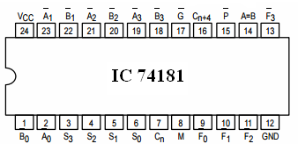
Fig 9.1 Pin diagram of IC used

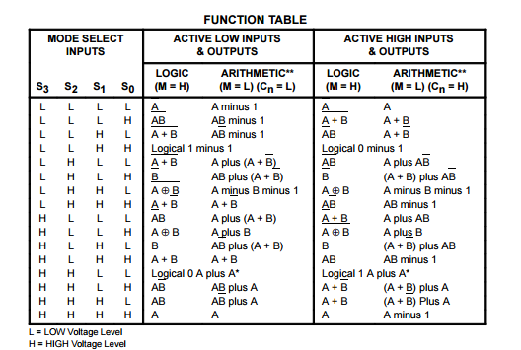
Table 9.1 Functional description of ALU IC

PROCEDURE:
- Keep the datasheet of IC 74181 ready.
- Insert the IC on the Breadboard.
- Make connections as shown in figure .
- Verify the connections.
- LEDs are connected at the input A and B lines and the select lines to indicate the value of the inputs A and B. The LEDs at the select lines are used to specify the function of the ALU.
- The LEDs at the output are used to test and verify the output.

RESULT:
The above circuit when connected to power supply gives correct result as per the function table.

PRECAUTIONS:
- Make the connections according to IC pin diagram
- The connections should be tight.
- The Vcc and the ground should be applied carefully at the specified pin only.

EXPERIMENT 10
REALIZATION OF SERIAL ADDER

AIM: To realize serial adder

APPARATUS REQUIRED: IC 7408(AND Gate), IC 7432(OR Gate),IC 7486(XOR Gate), IC 7476(J K Flip Flop, IC 7404(NOT Gate), resistor(1k), capacitor(.1uF), diode, LEDS, connecting wires, breadboard, power supply.

THEORY: Parallel adder performs the addition very fast but the disadvantage of this adder is that it requires large number of gates. One the other hand in serial adder the addition is done bit-by-bit. Serial adder requires simple circuitry as compare to parallel adder at the expense of low speed of serial adder. , 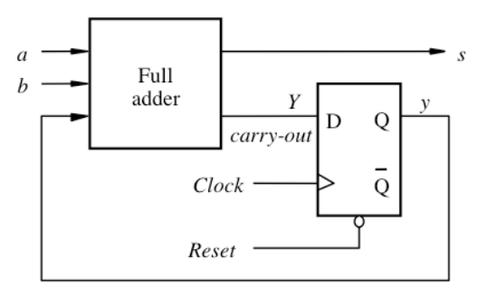
Fig 10.1 Serial Adder using D flip flop

A serial adder adds a pair of binary numbers serially with a simple full adder. The carry out of the full adder is transferred into a D flip-flop and the output of this carry flip-flop is then used as the input carry for the next pair of significant bits. The two binary numbers to be added serially are stored in two shift registers. Bits are added one pair at a time through a single full adder (such as the one in Experiment 4) The carry out of the full adder is transferred into a D flip-flop. The output of this carry flip-flop is then used as the input carry for the next pair of significant bits. The sum output from the full adder is transferred into register A as the contents of the register are shifted out.

TRUTH TABLE OF SERIAL ADDER
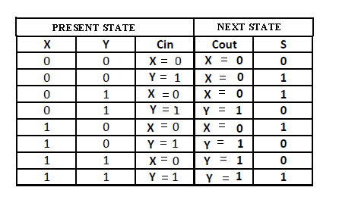
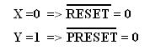
Table 10.1 Working of serial adder

CLOCK GENERATOR CIRCUIT

Fig10.2 Clock Circuitry

PIN DIAGRAM OF IC 7476
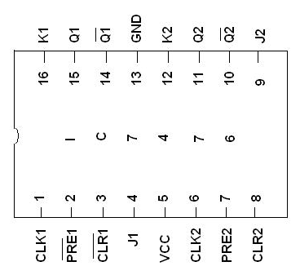
Fig 10.3 Pin Diagram of IC used

PROCEDURE:
- Make the circuit of full adder using logic gates (XOR,AND,OR).
- Make D-flip flop using IC-7476.
- Connect the D-input of the D flip flop to the carry output of full adder and Q output of flip-flop to carry input of full adder.
- Give the clock input to the flip-flop using Clock Generator circuit shown above.
- By giving Logic low to Preset and Reset inputs one by one in IC 7476(Cin=0 means active low reset = 0 and Cin=1 means active low preset = 0), verify the truth table of serial adder.

RESULT:
Serial adder has been realized successfully.

VIVA -VOCE QUESTIONS:
- State differences between serial and parallel adder.
- What is the requirement of flip flop in the serial adder circuit
- Explain why serial adder is sequential and parallel adder is combinational.

EXPERIMENTS BEYOND CURRICULUM

EXPERIMENT No. 11
REALIZATION OF MAGNITUDE COMPARATOR

AIM: To realize 2 bit Magnitude Comparator

APPARATUS: Breadboard, IC 7400 (NAND), IC 7410 (3 input NAND), IC 7404(NOT), LEDs, 5V power supply, connecting wires.

THEORY: Magnitude Comparator is a logical circuit, which compares two signals A and B and generates three logical outputs, whether A > B, A = B, or A < B. The outcome of comparison is specified by three binary variables that indicate whether A>B, A=B, or A<B. 2-Bit Magnitude Comparator Compares two numbers each having two bits (A1, A0 & B1, B0).

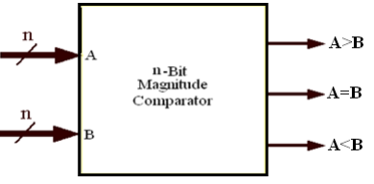
Fig 11.1 Block Diagram Of comparator

Designing of 2 bit comparator
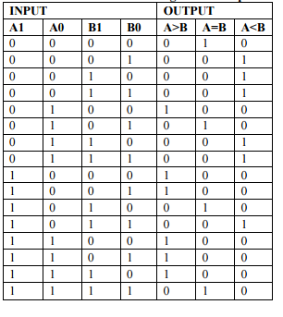

K-Map is used to minimize Boolean function obtained from truth table as shown below

a) FOR A>B FOR A=B
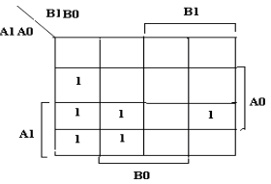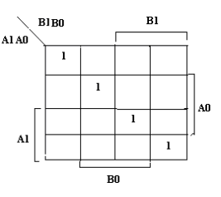
FOR A<B

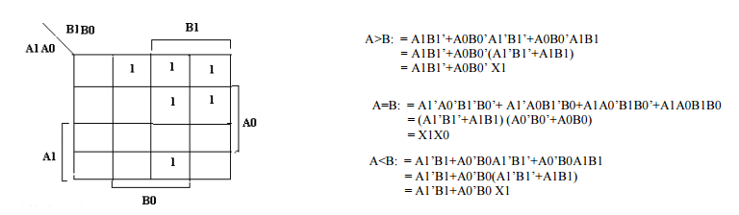
b)
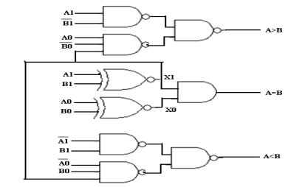
Fig 11.2 a)K Map minimization b) logic Diagram of comparator
PROCEDURE:
• Check all the components for their working.
• Insert the appropriate IC into the IC base.
• Make connections as shown in the circuit diagram.
• Verify the results and observe the outputs.
PRECAUTIONS:
1. All ICs should be checked before starting the experiment.
2. All the connection should be tight.
3. Always connect ground first and then the supply.
4. Switch off the power supply after completion of the experiment.

RESULT:
2 bit magnitude comparator has been studied and its truth table is verified.

VIVA -VOICE QUESTIONS:
- Write down expressions for 3-bit magnitude comparator.
- What are applications of magnitude comparator?
- What are Magnitude comparators?

EXPERIMENT No.12
REALIZATION OF BOOLEAN FUNCTION USING MUX

AIM: To realize a given boolean function using IC 74153.

APPARATUS: Breadboard, IC 7404 (NOT), IC 74153 (dual 4to1 mux), LEDs, 5V power supply, connecting wires.

THEORY:
Realization of functions using IC 74153-
(1) Implement the function F(A,B) = ∑(0,1,2) using a single 4-to-1mux
While implementing this function A,B will become the select input of the mux and the output will be F as shown in fig 12.1.

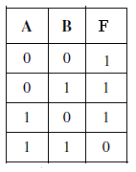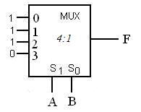
Fig 12.1 Truth table and diagram of Function

2) Implement the function F(X,Y,Z) = ∑(0,1,3,6) using a single 4-to-1mux and an inverter.
We choose the two most significant inputs X, Y as mux select lines. – Construct truth table: • We Determine multiplexer input line i values by comparing the remaining input variable Z and the function F for the corresponding selection lines value i:
when XY=00 the function F=1 (for both Z=0, Z=1) thus mux input(0) = 1
when XY=01 the function F=Z thus mux input(1) = Z
when XY=10 the function F=0 (for both Z=0, Z=1) thus mux input(2) = 0
when XY=11 the function F=Z’ thus mux input(3) = Z’
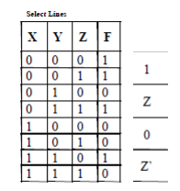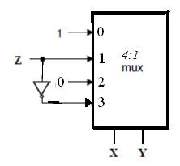
Fig 12.2 Truth Table and Diagram

PIN CONFIGURATION OF IC 74153:

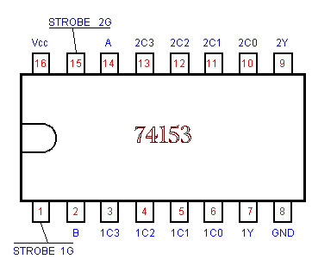
Fig12.3 Pin configuration 74153

PROCEDURE:
1. Check all the components for their working.
2. Insert the appropriate IC into the IC base.
3. Make connections as shown in the logic diagram.
4. Verify the results and observe the outputs.
- Connect Strobe 1G and Strobe 2G to ground.

PRECAUTIONS:
1. All ICs should be checked before starting the experiment.
2. All the connection should be tight.
3. Always connect ground first and then the supply.
4. Switch off the power supply after completion of the experiment.

RESULT:
Half Adder and Full Adder have been implemented using MUX IC and truth table has been verified.

VIVA -VOICE QUESTIONS:
- How many multiplexers are there in 74153 IC and what is their configuration?
- What is function of Enable pin?
- How many 2x1 mux required making EX-OR gating?

EXPERIMENT No. 13
REALIZATION OF CODE CONVERTER

AIM: To realize gray to binary and binary to gray code converter.

APPARATUS: Breadboard, IC 7486 (XOR), LEDs, 5V power supply, connecting wires.

THEORY: The gray code is a non weighted code. The successive gray code differs in one bit position only that means it is a unit distance code. It is also referred as cyclic code. It is not suitable for arithmetic operations. It is the most popular of the unit distance codes. It is also a reflective code. An n-bit Gray code can be obtained by reflecting an n-1 bit code about an axis after 2^{n-1} rows, and putting the MSB of 0 above the axis and the MSB of 1 below the axis. The below solved examples may useful to understand how to perform binary to gray and gray to binary code conversion. This conversion method strongly follows the EX-OR gate operation between binary bits.

Method of Conversion
a)
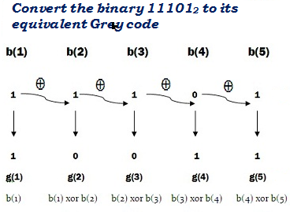

b)
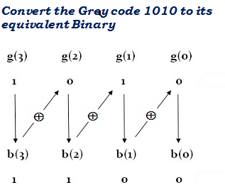
Fig 13.1 a) Binary to gray b) Gray to Binary

Logic Diagrams
a)
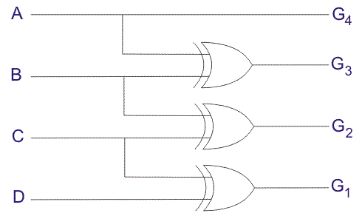

b)
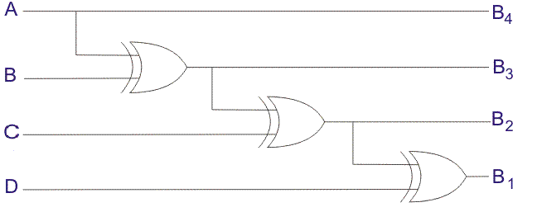
Fig 13.2 Logic Diagram of a) Binary to Gray b) Gray to Binary

PROCEDURE:
• Check all the components for their working.
• Insert the appropriate IC into the IC base.
• Make connections as shown in the circuit diagram.
• Verify the results and observe the outputs.

PRECAUTIONS:
1. All ICs should be checked before starting the experiment.
2. All the connection should be tight.
3. Always connect ground first and then the supply.
4. Switch off the power supply after completion of the experiment.

RESULT:
Gray to binary and binary to Gray code converter has been studied and its truth table
is verified.

VIVA -VOICE QUESTIONS:
- Why Gray code are called Unit Distance Code?
- What are applications of Gray Codes?
- What are Reflected codes?
- Why Gray Coding is used in K- mapping instead of binary?

EXPERIMENT No. 14
REALIZATION OF T FLIP FLOP

AIM: To design T flip flop using J-K flip flop IC or by kit.

APPARATUS: Breadboard, IC 7476 (J-K f/f), LEDs, 5V power supply, connecting wires, Omega LTB-826 kit and patch cords
THEORY: The name T flip-flop is termed from the nature of toggling operation. The major applications of T flip-flop are counters and control circuits. T flip flop is modified form of JK flip-flop making it to operate in toggling region.
Whenever the clock signal is LOW, the input is never going to affect the output state. The clock has to be high for the inputs to get active. Thus, T flip-flop is a controlled Bi-stable latch where the clock signal is the control signal. Thus, the output has two stable states based on the inputs which have been discussed below in fig14.1.
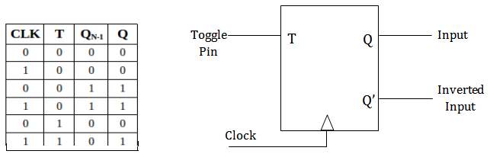
a) Block diagram and Truth Table of T flip flop

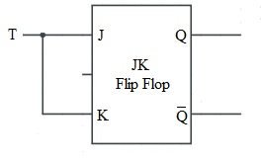 Fig 14.1 a),b) T-flip flop from J-K flip flop

Pin Configuration of IC 7476
Fig 14.2 Pin Diagram of 7473

PROCEDURE:
• Check all the components for their working.
• Insert the 7473 IC into the Breadboard.
• Make connections as shown in the circuit diagram.
• Verify the results and observe the outputs.
On kit: make connections on kit as per circuit diagram using patch chords.

PRECAUTIONS:
- All ICs should be checked before starting the experiment.
- All the connection should be tight.
- Always connect ground first and then the supply.
- Switch off the power supply after completion of the experiment.

RESULT:
The T flip flop has been studied and its truth table has been verified

VIVA -VOICE QUESTIONS:
1. What does T stand for in T flip flop?
2. List Basic T Flip-flop applications.
3. How many J-K flipflop are there in 7473 Ic?
4. What is difference between edge triggering and level triggering?

